Water Quality of Five Rice County Lakes

Environmental Geology
Professor Bereket Haileab
May 30, 2003
Walker DePuy, Nadia Elnagdy, Ann Leach, Dan Shinn-Krantz

Introduction:

The goal of our study is to determine the water quality of five lakes in western Rice County: Kelly-Dudley, Cedar, Roberds, Hunt, and Rice. Kelly-Dudley Lake is located on the northwest side of Faribault, MN. It is on the small side, taking up only about 120 acres. Cedar Lake is located dead west of Faribault, in a southwest direction from Kelly-Dudley Lake. It dwarfs Kelly-Dudley Lake, covering 804 acres. Roberds Lake is located on the northwest side of Faribault, MN covering a relatively large area at 654 acres. Hunt and Rice Lakes are both located due west of Roberds Lake, with Rice lake covering an area around 300 acres and Hunt Lake covering a little over 120 acres (Heiskary, 2000). From June 1999 to September 1999, the Minnesota Pollution Control Agency monitored Kelly-Dudley, Cedar, and Roberds Lakes. Measurements were taken of oxygen concentration, total phosphate concentrations (TP), total nitrate concentrations (TN), chlorophyll-a levels, Secchi transparency, pH, and conductivity. The study reported that TP and TN concentrations in Kelly-Dudley Lake were typical for the region; chlorophyll-a levels were low, Secchi transparency levels high, and TP was the limiting nutrient. Cedar Lake conductivity and pH levels were normal for the region, and Roberds Lake followed along the same lines, with high ph and lower conductivity in the upper waters, and low pH and higher conductivity in the lower waters (Heiskary, 2000).
We compared our findings to the 1999 study and current Minnesota water quality standards and found that the water quality of at least three of the lakes hasn't changed significantly over the past four years. Additionally, the results that we gathered do not exceed and are in fact much lower than the water quality standards prescribed by the state of Minnesota. We believe that the cleanliness of these lakes is due to their small watershed to lake ratios and land use patterns around the lakes.
Procedure:
Over an eight-week period we traveled to each of these lakes three to four times, first locating it on a GPS and then performing several tests on site. Cedar, Hunt, and Rice Lakes were sampled on April 22, May 9, and May 13; Kelly-Dudley and Roberds Lakes were sampled on April 15, April 22, May 5, and May 13. Color, conductivity, temperature, salinity, and turbidity were measured. We also collected a sample of the water in plastic bottles for later lab analysis. To be consistent we measured at what depth we tested these things and tried to keep the test site constant. To measure color, we examined the lake close to us and far away, noting the effects of vegetation and sediment in altering its color from clear to green or brown or any mixture in between. In measuring for conductivity, salinity, and temperature, we used the Yellow Spring Instruments, Incorporated, Model 85 (YSI). The sensing rod, which when placed in the water, calculates a variety of information. Conductivity can be described as the measurement, based on lake temperature, of mineral content and elements in a sample of water. Turbidity is the measurement of a particular lake’s murkiness, i.e. how much organic matter and sediment is suspended in the lake and how much light can get through. The turbidity of a lake is important because this murkiness inhibits sunlight penetration of the water surface and thus the growth of plants underneath, contributing to a less healthy lake habitat. We measured turbidity with a transparency tube, which is filled with water and then drained out the bottom until the black and white symbol at the bottom of the tube becomes visible. Once the disk is visible, the height of the water in the tube is recorded, and this is now the calculated murkiness of the water. Temperature is measured in Celsius, and Salinity (salt content) is found in parts-per-thousand or ppt.
We looked around at the landscape and gathered any additional information regarding the status of the lake and its surrounding area. This includes wildlife sightings, human interaction, litter in or around the lakes, boats docked or out on the water, and land use. Using the Ion Chromatograph, we analyzed the respective water samples for several anions, including Chloride, Nitrite, Nitrate, Fluoride, Bromide, Phosphate, and Sulfate in order to judge the lakes’ overall health and element content.
Results:
Overall, the color for each lake was consistent, as far as we could tell (our measurement may have been influenced by atmospheric conditions or our own individual perceptions). Cedar, Hunt, and Rice maintained a murky greenish brown color, and Kelly-Dudley and Roberds appeared clear.
The conductivity of the lakes was also fairly stable (see Figure 1).
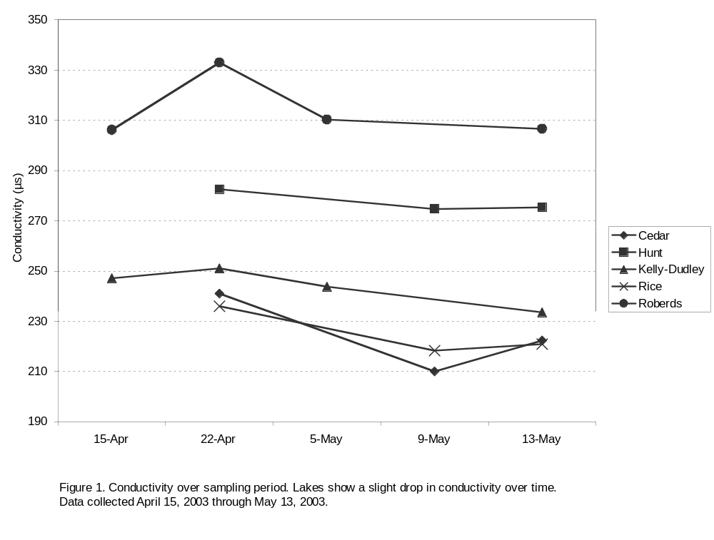
The salinity of each lake measured 0.1 ppt every sampling day with one exception: Roberds Lake showed a salinity value of 0.2 on April 22, which we believe to have been an error because the samples on the following sample days measured the usual 0.1 ppt.
The trends in the turbidity data varied by lake (see Figure 2). The turbidity of Cedar Lake increased over time. Kelly-Dudley and Roberds Lakes remained clear. Hunt and Rice Lakes showed a decrease and then an increase in turbidity over the sampling period.
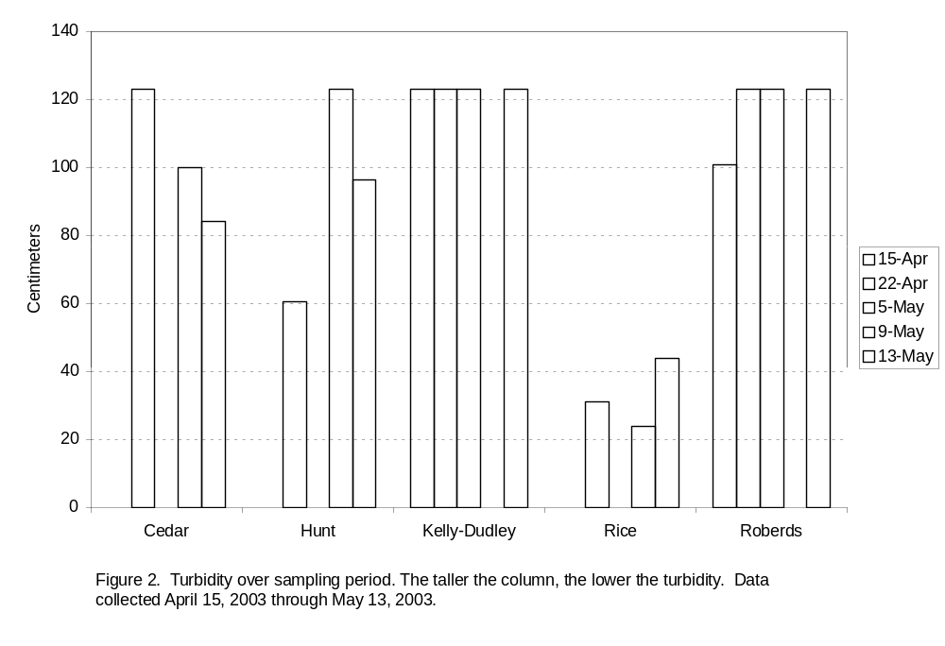
The lakes show a rise in temperature over the eight week period, although the temperatures of Kelly-Dudley and Roberds Lakes decreased quite a bit on May 5 (see Figure 3). We think this may be due to heavy rainfall (.96 inches) on the night of May 4 (see Figure 8); however, we have no way to determine this.
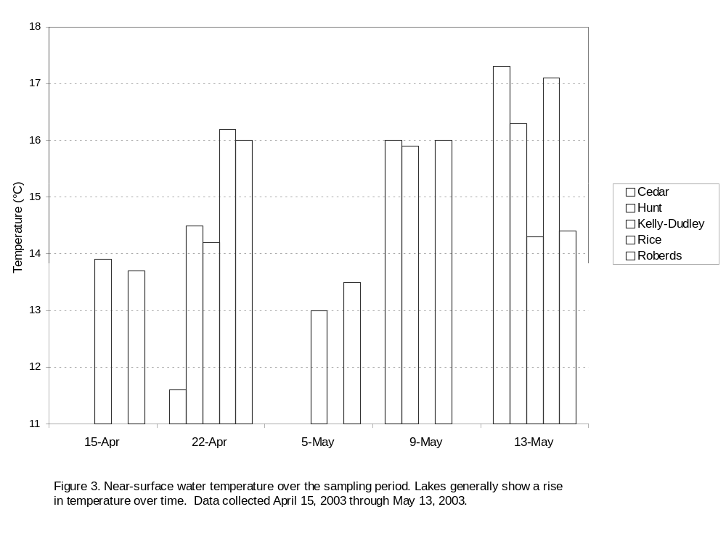
The chloride levels in the lake fluctuated over time, but usually less than 1 ppm, which is within reasonable error (see Figure 4). We saw the same kind of trend in the results for fluoride (Figure 5), sulfate (Figure 6), and nitrate (Figure 7).
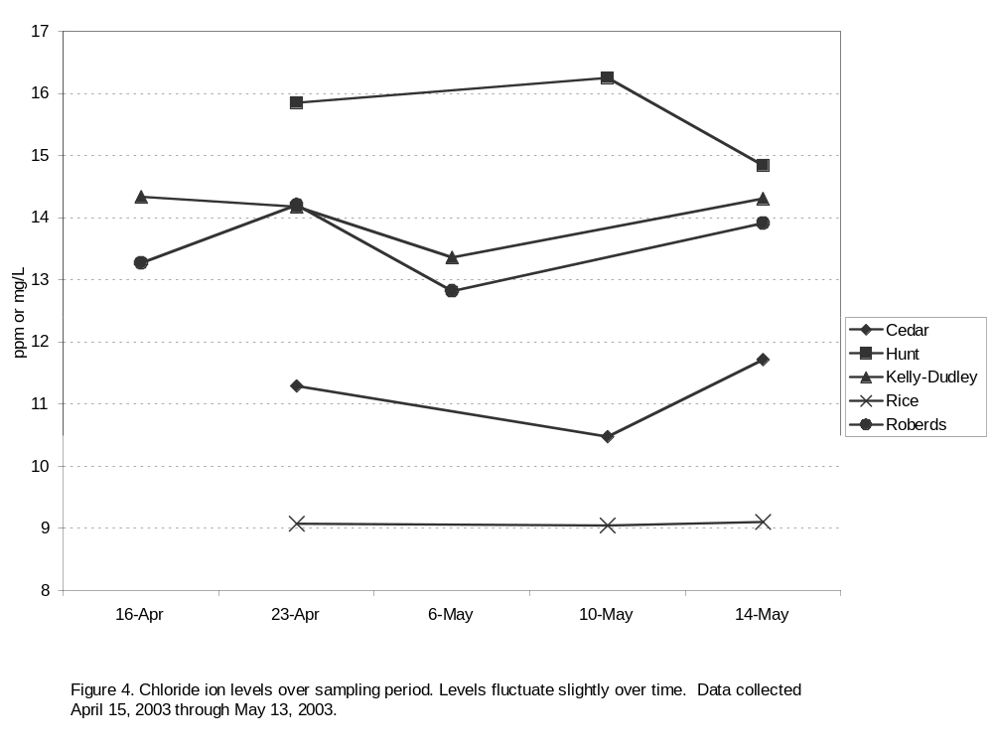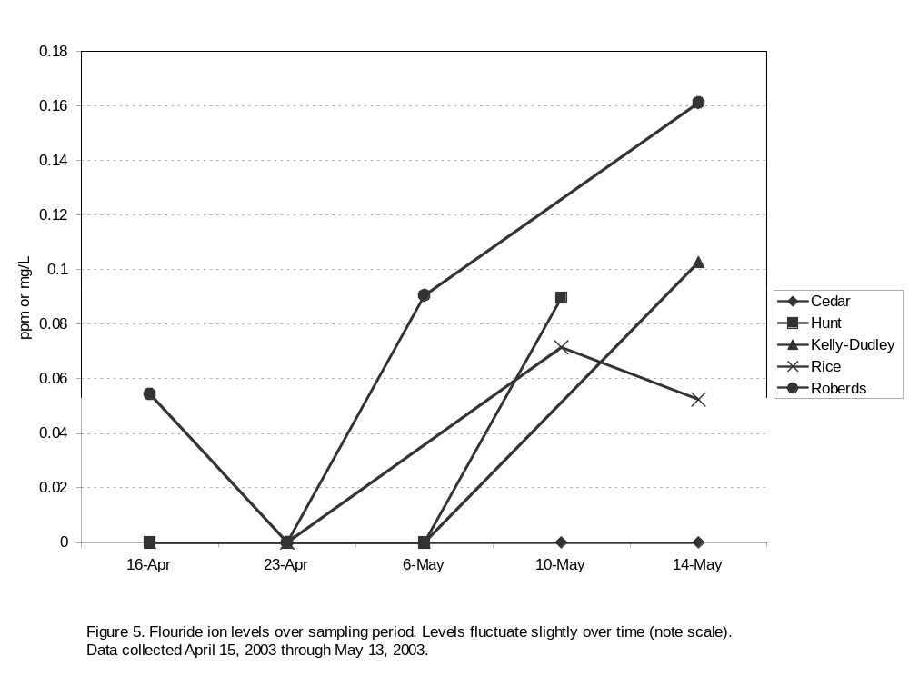
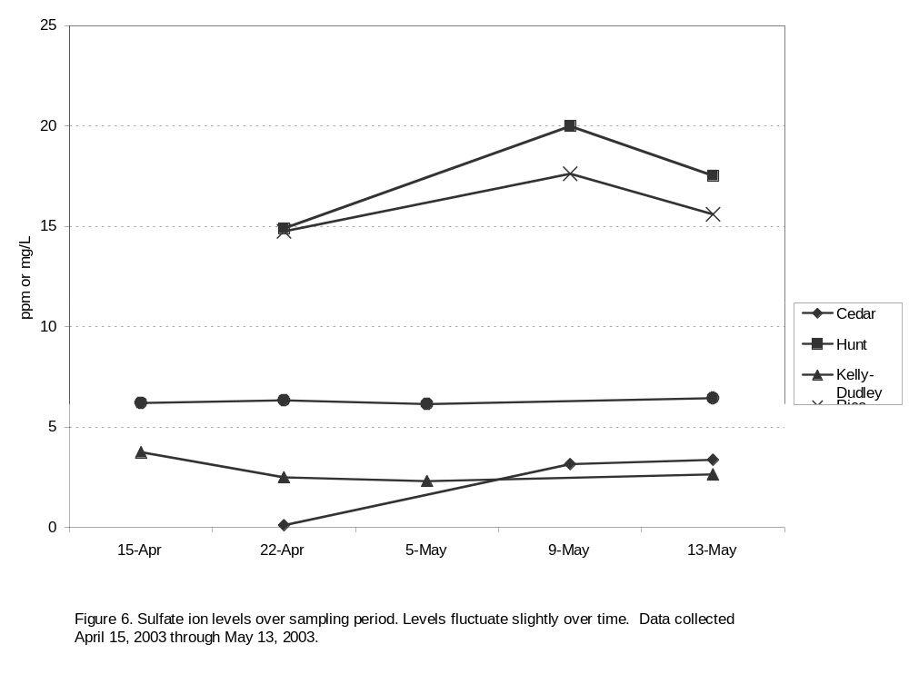
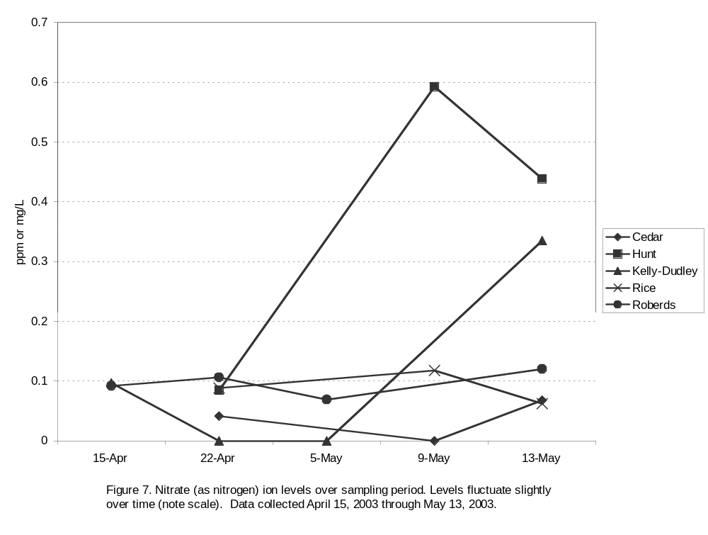

The Ion Chromatograph found no traces of bromide or phosphate in our water samples and yielded only one result of nitrite. On April 22nd, Cedar Lake showed a nitrite level of 0.99 mg/L, which we believe to be an error, since the two subsequent samples yielded no nitrite.
Our observations of the surrounding lakes also gave us an idea of the wildlife that frequent the lakes. Most of the lakes had signs that indicated the types of fish that could be found. These included bass, walleye, northern pike, sunnies, crappies, and carp. Bird sightings included loons, herons, white pelicans, redwing blackbirds, Canadian geese, and ducks. Other wildlife included dragonflies, frogs, and turtles. Additionally we saw many signs of human life – houses, boats and boat ramps, oil on the water, and litter on the shore.
The daily rainfall over the sampling period (Figure 8) may also be useful.
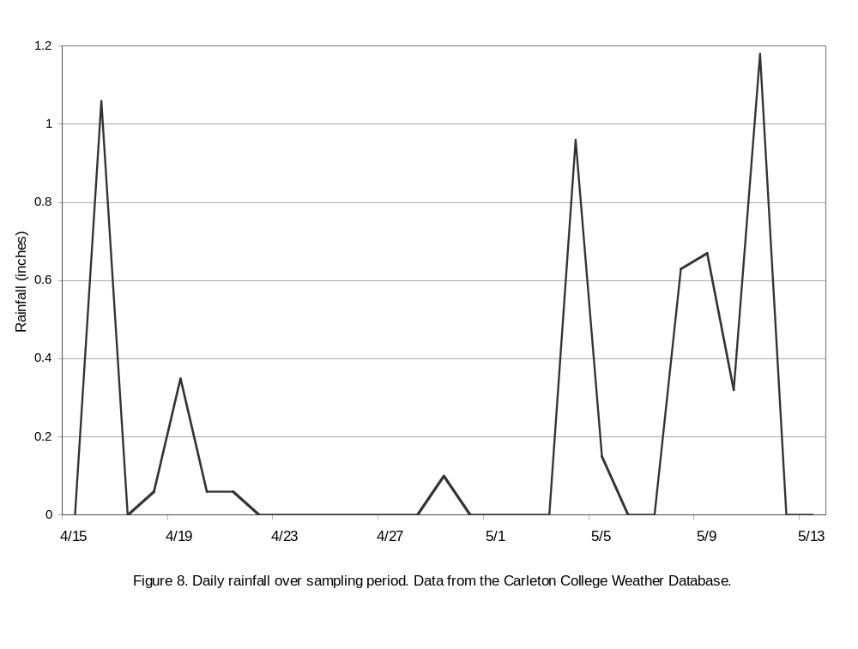
GIS data also yielded information about the land use in the watershed areas around our lakes. Cedar Lake has streams flowing through, cultivated land, rural residential complexes, other rural development, deciduous forests, wetlands, grasslands, and islands containing mostly deciduous forest, with some grassland. Hunt Lake has farmsteads, rural residential development complexes, cultivated land, grasslands, deciduous forests, a stream nearby, and some wetland. The Cannon River flows directly through this section, but is not near the lake. Kelley-Dudley Lake has major wetland areas, grassland, deciduous forest, rural residential complexes, cultivated land, and gravel pits near the wetlands. Rice Lake has farmsteads, cultivated land, grassland, deciduous forest, streams flowing through, the Cannon River flowing through, and wetlands. Roberds Lake has streams flowing through, deciduous forests, grasslands, farmsteads, wetlands, cultivated land, and rural residential complexes.
Discussion:
We sampled our lakes at only one site at each lake and for only two months. To get an idea of how typical our results were, we compared them with the results of an earlier 1999 study conducted by the Minnesota Pollution Control Agency (Heiskary, 2000). Their study did not include Hunt or Rice Lakes, but we have comparison data for Cedar, Roberds, and Kelley-Dudley Lakes. The chloride levels we measured were typical: both our measurements and the 1999 measurements showed chloride levels hovering between 10 and 14 mg/L, for the three lakes (Heiskary, 2000). Hunt and Rice Lakes were respectively slightly above and below this range. The 1999 study reported an average conductivity of 290 mg/L for Roberds Lake, making our conductivity measurements (238-275 mg/L) somewhat, but not substantially, below average. In contrast, our conductivity measurements for Cedar and Kelley-Dudley Lakes were somewhat above the 1999 averages (250 and 250-260 mg/L respectively).
We also compared our anion results to water quality standards prescribed by the Environmental Protection Agency, specifically the Minnesota Pollution Control Agency. The levels we measured in our study were well below the acceptable standards for all lake uses. These uses include aesthetic enjoyment and navigation, domestic consumption (drinking water), industrial consumption, agricultural irrigation, and agricultural livestock and wildlife use. For chloride, the standards given are 250 mg/L for domestic consumption, and 50 –100 mg/L for industrial consumption. The maximum chloride level we found was 16.25 mg/L in Hunt Lake on May 9. For fluoride, the standard given is 2-4 mg/L for domestic consumption. The maximum fluoride level we found was 0.16 mg/L in Roberds Lake on May 13. For nitrate as N, the standard given is 10 mg/L for domestic consumption. The maximum nitrate level we found was 0.59 mg/L in Hunt Lake on May 9. For sulfate, the standard given is 250 mg/L for domestic consumption. The maximum sulfate level we found was 19.99 mg/L in Hunt Lake on May 9 (MPCA, 2003).
While the changes in anion levels were slight (a few parts per million at most), we believe these changes may have been caused by rainfall washing them into the lakes through streams or groundwater leaching, since the changes occurred after rainstorms. However, the changes in anion levels may also be attributed to error but are within acceptable error standards.
Our data has lead us to conclude that the water quality of these lakes is good, however, this conclusion conflicts with the earlier 1999 study, most specifically in the case of Roberds Lake. The authors of the study deemed the lake unhealthy due to their study of phosphorus levels, lake temperature at different depths, and oxygen content (Heiskary, 2000). Since our study did not include these measurements, we suggest that future tests should be done to determine if the data is the same or has changed in the past four years.
The size of a lake’s watershed and the land-use patterns within that watershed are major factors affecting water quality. The 1999 study theorized that the ratio of watershed area to lake area would affect the load of phosphates and other nutrients that would runoff into the lake (Heiskary, 2000). None of our lakes have particularly large ratios, although the Roberds Lake ratio is medium-sized. Under this theory, the relatively small ratios may contribute to the relative cleanliness of these lakes. The theory does not gain any additional support from our data, but may prove useful in comparing our lakes with other lakes in the region.
The land-use patterns are also likely to contribute to water cleanliness. Most of the cultivated land near our lakes is separated from them by other features such as forests and grasslands, probably limiting its effect on the lakes, whereas other bodies of water have farmland right up to the edge of their banks, increasing the effects of runoff. Rural development also exists around all of our lakes, but is generally not extensive and probably has a limited effect. Grasslands and forests may also play a role in protecting the lakes. One feature that particularly jumped out at us was a line of gravel mines above the wetlands near Kelley-Dudley Lake. It would be prudent to conduct a study to find out if and how the mines affect the wetlands and how the wetlands affect the lake.
Conclusion:
From what we know about the variables we measured we have concluded that all five lakes are clean. In particular, our results in comparison to water quality standards are remarkable. The comparisons between our measurements and the 1999 measurements lead us to believe that chloride levels in our lakes have been fairly constant over the past few years and that conductivity has a range of normal variation over the course of a year. There are many other measurements that the 1999 study took that we did not take and vice versa; it would be useful for future studies to be more comprehensive (particularly with measures such as total phosphorous, ph, and dissolved oxygen).

Acknowledgements:
We’d like to thank for all their help and support: Professor Haileab, Liz Clark, Heather Hilchey, Melissa Keevil (for her companionship, instruction, and navigational skills), the Geology Department, , Professor Savina, and the surrounding lake and stream groups. Without their knowledge and time, we could not have mastered GIS, Adobe Illustrator, or any other key parts that made this paper possible.

References:

Heiskary, Steve. April 2000. “Status and Trend Monitoring Summary for Rice County,
Minnesota 1999 (Lakes: Cannon, Wells, Kelly, Dudley, Circle, Cedar, and Roberds).” Done by Minnesota Pollution Control Agency: Environmental Outcomes Division, Environmental Monitoring and Analysis Section. 3-37.

Minnesota Pollution Control Agency. 12 February 2003. “Waters of the State: Chapter
7050.0220, Specific Standards of Quality and Purity by Associated Use of Classes.” http://www.revisor.leg.state.mn.us/arule/7050/0220.html. Found 14 May 2003.

