Cannon River Study

Nat Beebe, Kirstin Duffin, Anna Layman, Emily Schwing

Introduction
This study analyzes the Cannon River around the areas of Northfield and Faribault, Minnesota. Our group took water samples between April 15, 2003 and May 13, 2003 to determine the water quality; this research adds to the body of literature that already exists on the Cannon. In 1996 the Cannon River Watershed Partnership did a study to monitor the river water. Two Carleton students also did their comprehensive exercise on the Cannon in 1976. Their results can be found in the Carleton College Gould Library, along with the Cannon River Watershed Partnership data. The United States Geological Survey has made data on the Cannon River available online.
While collecting water samples from six different sites in and around Northfield and Faribault, we conducted readings on the Cannon for temperature, turbidity, salinity, pH levels, conductivity, and dissolved oxygen. We also tested the water samples for the following nutrients: sulfate, fluoride, chloride, bromide, nitrite, nitrate and phosphate. Using EPA standards we compared the Cannon test results to healthy nutrient levels of drinking water.
We were able to determine some contaminants in Cannon River water and their possible origins. As a viable water source for human consumption in Rice County, the actions of the Cannon River watershed affect the community. We have analyzed the results of five weeks of water samples to determine that the Cannon River water presents nutrient levels below EPA drinking water standards; this study also shows that the Cannon River generally acts in explainable patterns.

Methods and Instruments
Yellow Springs Instruments Incorporated, model 85 - This was the primary instrument used at each field site. The YSI-85 was used to measure conductivity, temperature, dissolved oxygen, and salinity. The YSI-85 collects measurements by placing a probe into the water sample, which then displays the readings onto a hand held module. The YSI-85 was both accurate and efficient in gathering data in the field.
pH meter - This instrument was used to measure both the pH and temperature of the water sample. The pH meter collects data by placing a probe into the water sample, which then displays the readings onto a hand held module. The pH meter was very helpful in the field, and eliminated the need to test the pH levels by hand.
Secchi tube - This instrument was used to determine the turbidity of the water sample. The Secchi tube is a long tube made out of a clear plastic, which at the bottom has a white and black disc attached. In order to measure turbidity, the tube is first filled full with water from the sample site, next water is released out of the tube by opening a valve which lets water flow out through a smaller tube installed near the bottom. As the water is released out of the Secchi tube the black and white disc begins to appear, when both the black and white part of the disc are visible, the valve is shut. In order to determine the turbidity level a ruler is attached to the outside of the Secchi tube, which gives the distance from the disc to the water level. The water clarity is high if the measurement on the Secchi tube is too.
Ion Chromatograph - This instrument was used to measure Phosphate, Chloride Fluoride, Bromide, Sulfate, Nitrite, and Nitrate. In order to test for these elements and water sample must be collected from the site and then brought back to the machine for analysis. Once the water has been collected it must then be forced through a small mesh screen in order to filter out fine sediments and other materials, which might clog the Chromatograph. After the water sample has been filtered it is placed in the Chromatograph, which measures each of the elements and displays the information in a graph. This information is stored in a computer and later can be printed out. The Ion Chromatograph is a very precise machine, which can measure one water sample in about eight minutes, and it is the same machine that Environmental Protection Agency uses to test drinking water.
Test Sites

We consistently tested five sites: Rice Creek, Wolf Creek, Highway 3, Faribault, the Northfield Dam, and Lyman Lakes. All were located within or between Northfield, Minnesota and Faribault. Additionally, we collected one sample at each of two additional sites: the Mississippi and above Lyman Lakes.
Rice Creek - This site is located about .5 miles West of the junction of Highway 3 and Highway 19 in Northfield MN. Water samples were taken a few meters downstream of where Rice Creek flows into the Cannon River to ensure the sample was water from the Cannon River and not merely Rice Creek water. A total of six samples were collected from the Rice Creek sample site from April 15,2003 thru May 13, 2003.
Wolf Creek - This site is located approximately 2 miles West of Northfield MN off of Highway 3. Water samples were taken a few meters downstream of where Wolf Creek flows into the Cannon River. A total of six samples were collected from the Wolf Creek sample site from April 15, 2003 thru May 13,2003.
Highway 3 - This site is located off the side of Highway 3, at mile marker 5. Water samples were taken from the bank of the Cannon River in the first wooded area a few meters west of mile marker 5. After several weeks of heavy rain, this site became flooded and forced us to take the water sample closer to the road on our last sampling date. A total of six samples were collected from the Highway 3 sample site from April 15, 2003 thru May 13,2003.
Faribault - This site is located off Highway 3 in downtown Faribault MN, directly behind the Faribault foods factory. Water samples were initially taken directly on the stream banks, but do to heavy rains each subsequent sample was taken farther away from the initial location. A total of five water samples were collected from the Faribault sample site from April 22, 2003 thru May 13, 2003.
Northfield Dam - This site is located in downtown Northfield MN. Water samples were taken a few meters above the Dam, directly across from the Northfield Post Office. A total of six water samples were collected from the Northfield Dam site from April 15, 2003 thru May 13, 2003.
Lyman Lakes - This site is located off Highway 19, near Carleton College. Water samples were taken a few meters downstream of where the Lyman lakes stream flows into the Cannon River. Lyman lakes are located on the campus of Carleton College and are often home to hundreds of Geese in the fall. A total of three water samples were collected from the Lyman Lakes site from April 22, 2003 thru May 13,2003.
Mississippi – This site is in Redwing, Minnesota, where the Cannon River joins the Mississippi River. One water sample was taken here on May 10, 2003.
Above Lyman Lakes – This site is along the stream that feeds into Lyman Lakes, dividing the Carleton College soccer fields and the Carleton arboretum. It was tested once on May 13, 2003.
Observations
The sign of a healthy river comes from the organisms that thrive in it. A healthy water source is able to sustain many different forms of plant and animal life. We determined the Cannon River to be healthy because, among other things, we found living organisms in it. While visiting our test sites along the river, we saw an abundance of animal life. Over the course of our study, we saw herons, carp, ducks, geese, and turtles. In collecting water samples, some days we found water boatman and a couple of other small organisms swimming in the water; we also found a snail’s shell near the river. One day, we found a dead bullhead floating near the bank. Near it was another sickly bullhead. Confused as to why this might be, we think the extended period of rain may be at least in part to blame. A decreasing level of dissolved oxygen is another possible cause. Fish are healthy if the dissolved oxygen level is above 5 mg/L (Haileab, handout). While we found the dissolved oxygen to be above this amount, Figure 6 shows that the level is rapidly declining. The fish may not have been able to adjust to this change.
One source of pollution to the river, mentioned briefly above, is flooding. Over the course of our study of the Cannon River, it was possible to watch the impact of precipitation on the river’s water and contaminant levels. With almost total consistency, the Cannon got progressively deeper each time we visited. Spring rains makes flooding a common occurrence. The total precipitation during our study was approximately 21 centimeters, or a little over 8 inches (The Weather Underground, Inc.). The river rose much more than this. Rain draining from the land, and streams feeding into the Cannon, cause the additional rise in water level.
Results
Through testing six different points along the Cannon River, as well as three areas of water that either influence or are influenced by the Cannon, we have observed patterns and results. Figure 2 shows the changes in water temperature. For most sites it decreased from highs of 19.2 degrees Celsius over the dam in Northfield and 18.5 degrees Celsius at Rice Creek and on Highway 3 on April 15 to fluctuate between 10 and 15 degrees toward the end of the testing period, rising to a high of 16 degrees in Faribault on May 13. Warming temperatures were the general trend.
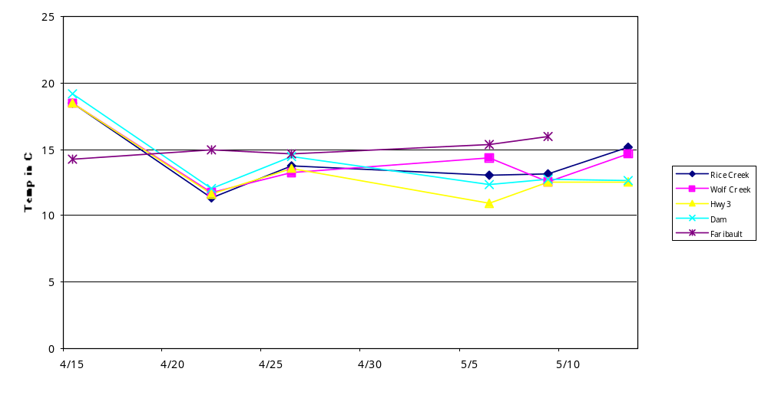Figure 2 – Water Temperature of Cannon

Turbidity levels of the Cannon River fluctuated throughout the month of testing. Several rainstorms helped to raise the level of the river. The river’s velocity increased during our study. After rainstorms the velocity of the main current increased; however, when the floodplains flooded, the water lying there was fairly stagnant. At the Highway 3 and Northfield Dam test sites, the turbidity levels increased from April 15 to April 22, rising from 35.2 on Highway 3 to 86.8 and 46.2 at the Dam to 79. The turbidity levels tended to decrease at those two sites, as well as at Rice Creek until May 9, when all of the turbidity levels rose, except for the level at the Northfield Dam, which continued to decrease from 85.6 on April 26 to 18.8 on May 13. Wolf Creek, Rice Creek, and the Cannon at Faribault all followed similar turbidity level patterns. The Faribault site consistently maintained some of the highest turbidity levels, reaching the highest recorded level for any site on May 13 at 95.6. While Wolf Creek followed a similar pattern, it reached the lowest turbidity level recorded on May 9 at 6.8, the same day that almost every point on the Cannon reached its lowest level. To analyze how the turbidity level of each site compares with the others, see the chart below. Figure 4 contains data from the Carleton College website, and it portrays the levels of rain in Northfield throughout the testing period.

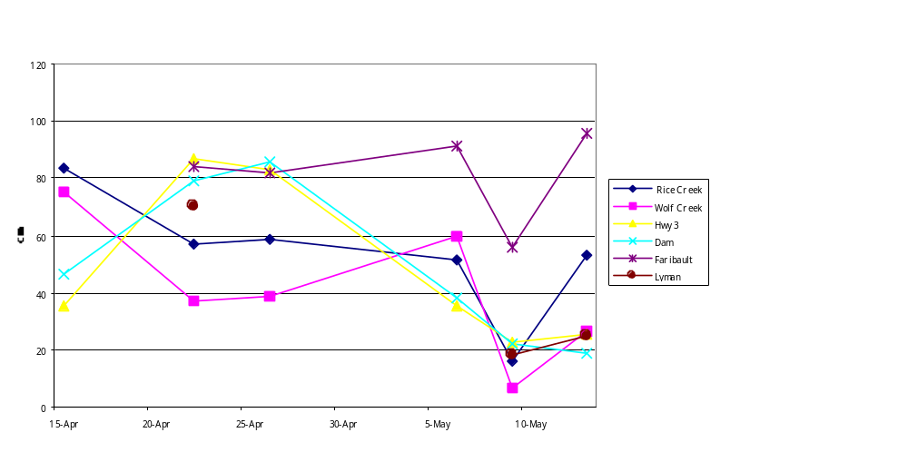Figure 3 - Turbidity
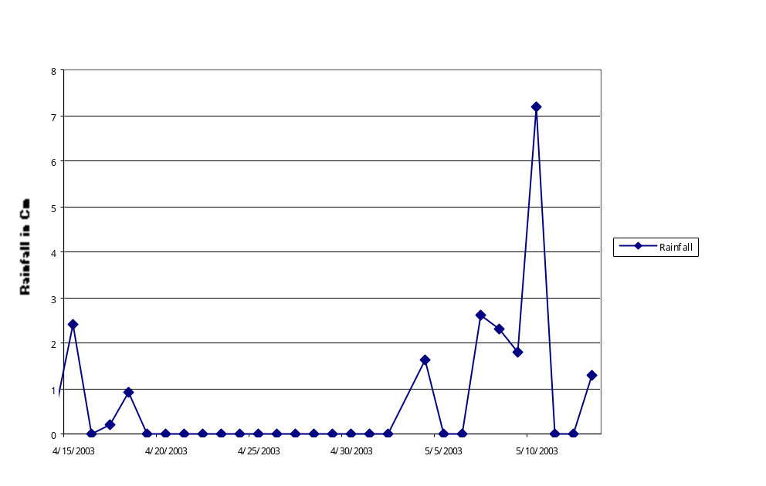
Figure 4 – Precipitation during April 14, 2003- May 15, 2003

Salinity levels for the Cannon River remained fairly steady, at 0.1 ppt to 0.3ppt. Wolf Creek, Rice Creek, and the Faribault site remained steady at 0.2 ppt, while the Northfield Dam and Lyman Lakes’ entry into the Cannon stayed steady at 0.3ppt. The salinity at the Highway 3 site showed the only drastic change, jumping from 0.1 to 0.3 between April 15 and April 22 and then remaining steady at 0.3 for the duration of the project.
The pH levels of these sites on the Cannon all were measured and mostly found to be basic. Rice Creek’s pH changed from 8.29 on April 26 to 8.65 on May 13. The pH on Highway 3 climbed similarly from 7.9 to 9.8. Wolf Creek’s pH, however, changed in the other direction, dropping from a pH of 8.0 on April 26 to 7.3 on May 13. At the Northfield Dam, the basic pH of 10 on April 26 dropped to 7.3 on May 13. Meanwhile, in Faribault the pH made a similarly sized jump in the other direction, going from a slightly acidic 6.9 to a very basic pH of 10. The researchers also measured the pH at Lyman Lakes’ entry to the Cannon at an acidic 6.65, while the pH of the stream above Lyman Lakes was 7.93 on the same day.
Conductivity levels of the Northfield Dam location, Lyman Lakes water at the Cannon, and Highway 3 all hovered between approximately 400 and 500 with Highway 3 reaching the high of 505 ms on April 22. The Faribault site, Wolf Creek, and Rice Creek all maintained lower conductivity levels, ranging from Wolf Creek’s low on April 22 of 278 ms to Rice Creek’s high of 366 ms on May 9. Each site increased its level of conductivity between May 6 and May 9 with the exceptions of Wolf Creek, which declined from 355.3 ms to 325 ms and the Northfield Dam, which remained steady at 457 ms. Likewise, from May 9 to May 13, every site’s conductivity declined with the exception of the Faribault site, which increased from 327 ms to 339.7 ms. Figure 5 below illustrates these findings.

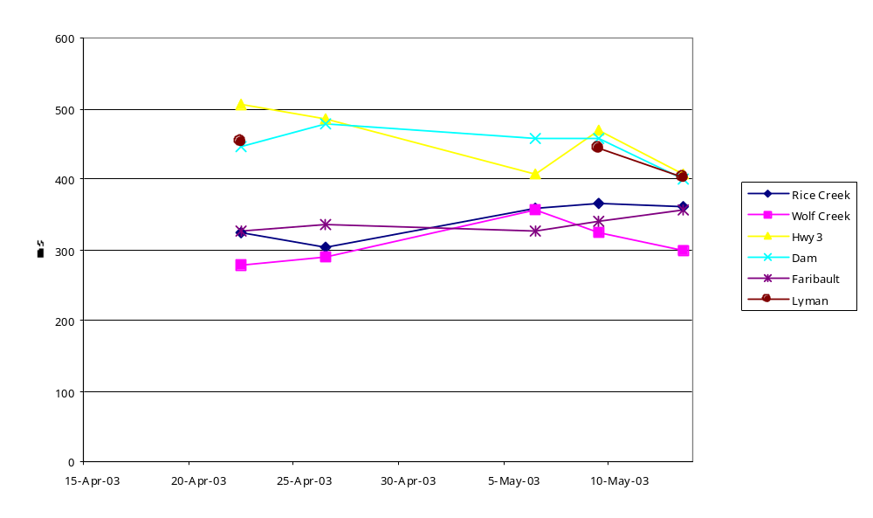
Figure 5 - Conductivity

The Northfield Dam site, Rice Creek, Lyman Lakes in the Carleton Arboretum, Faribault, and Wolf Creek follow a similar downward trend in dissolved oxygen levels. With the highest beginning level of 15.73 mg/L, the Northfield Dam’s level decreased throughout the testing period, ending on May 13 at a level of 6.22 mg/L. Wolf Creek’s similar decreasing trend at the end of the project with the lowest level of 4.4 mg/L. The site at Highway 3’s levels were much more erratic, jumping from 8.51 on May 6 to 17.4 mg/L on May 9, and then falling back to 6.7 mg/L on May 13. See Figure 6 below for complete results.
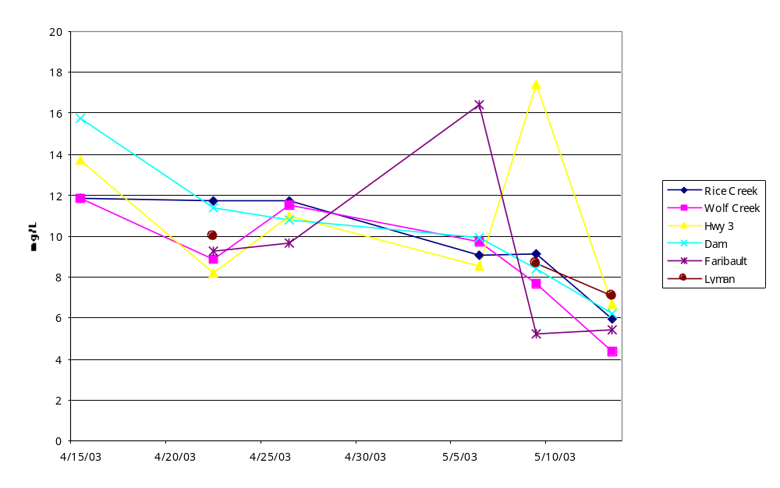Figure 6 – Dissolved Oxygen

Using the Ion Chromatograph, the researchers tracked the levels of certain components in the stream water. Throughout the testing period, the levels of sulfate at every location dropped considerably from their initial levels on April 15. The Highway 3 site’s level changed the most, ranging from the data’s overall high of 38.0395 mg/L down to the data’s overall low for sulfate at 16.3511 mg/L on May 13. Wolf Creek’s sulfate levels stayed between 24.012 mg/L on April 15 and 20.2004 at the end of the testing. Figure 7 displays the pattern of generalized sulfate content decline.
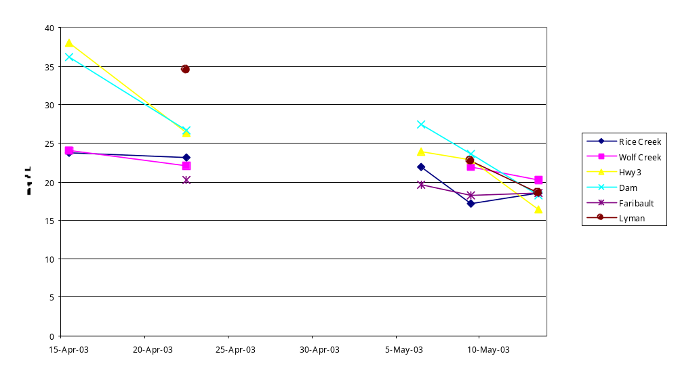
Figure 7 - Sulfate

According to the Environmental Protection Agency, drinking water must have less than 4.0 mg/L of fluoride (List of Drinking Water Contaminants & MCLs, 2003). All of the samples along the Cannon River were far below this level; the highest level measured was 0.5514 at the last sampling of Rice Creek. This sample, however, is much higher than the other samples taken, most of which hovered between 0.1 and 0.2 mg/L. Highway 3 samples consistently had higher levels of fluoride than the other sites’ samples, and the samples taken from the dam consistently were not far below. Figure 8 shows all fluoride measurements.
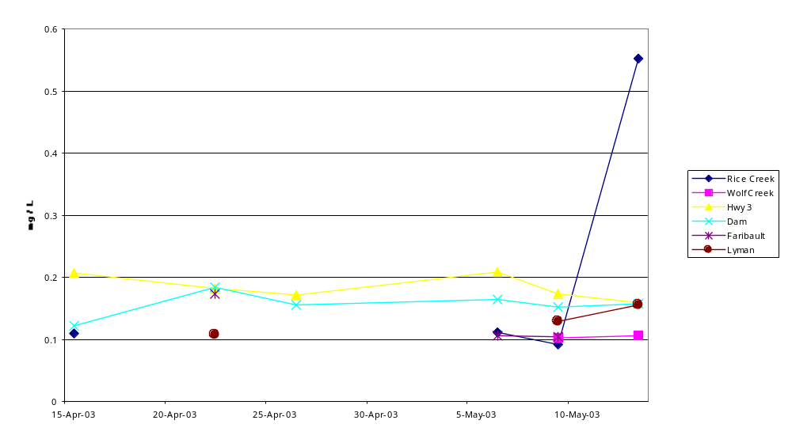
Figure 8 - Fluoride

Similar to the fluoride measurements, the chloride levels remained fairly consistent. 250 mg/L is the Secondary Standard put forth by the EPA (List of Drinking Water Contaminants & MCLs, 2003), and once again, the chloride levels in our samples did not reach that level. The chloride content declined similarly between April 15 and April 22 for Highway 3 and the Northfield Dam, moving from 37.5844 mg/L by Highway 3 to 27.8657 mg/L. Likewise, both Rice Creek and Wolf Creek’s chloride levels increased by a very small amount, Wolf Creek’s rising from 14.6319 mg/L to 14.8685 mg/L. All chloride levels began to decline at the May 6 sampling with Wolf Creek eventually reaching the lowest level on May 13 at 13.0609 mg/L. The trends are illustrated in Figure 9.

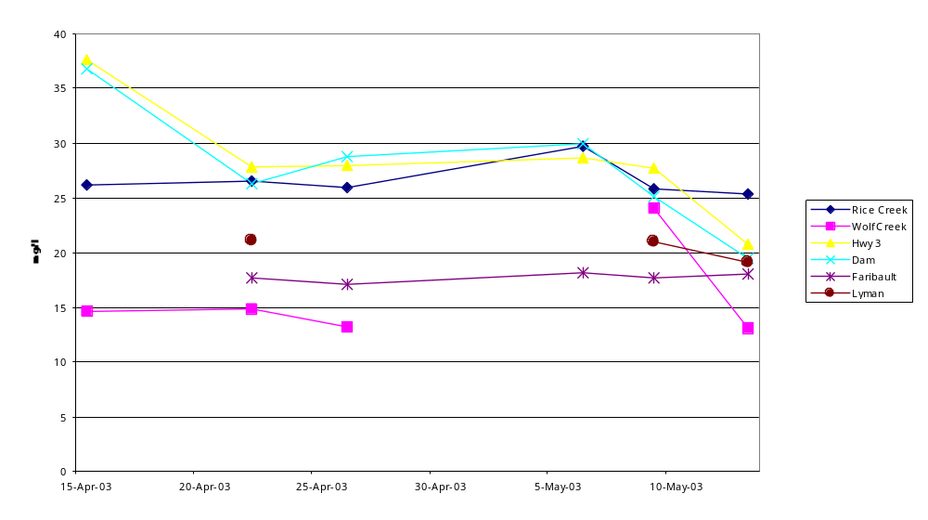
Figure 9 - Chloride

The nitrite levels of all the test sites were reasonably low. Several times during sampling no nitrites are found in the water. When nitrites are found in the water, the concentration is very low. Figure 10 illustrates that the highest concentration was 0.13 mg/L, which we took from Lyman Lakes on May 13. The Northfield Dam had the most consistent nitrite levels with nitrites in the water five out of the six testing day. Even though the Dam was consistent in reading, the levels always remained under 0.12 mg/L. 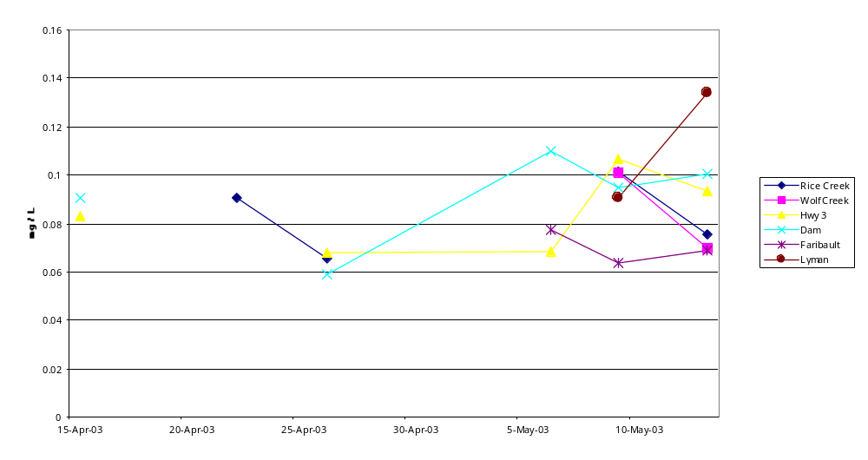Figure 10 - Nitrite

The nitrate levels unlike nitrite ranged in concentration depending on the site. The Northfield Dam and Highway 3 samples had the highest concentrations ranging from 2 mg/L all the way up to 8 mg/L. In fact the concentrations of these two sites seem very similar, almost running parallel to each other. The lowest concentration occurred in Faribault, which highest level was only 1.11 mg/L. The Faribault test site was always very low in nitrates and only increased above 0.4 mg/L once. Wolf Creek seemed to fall in the middle of all the other sites. It never reached too high of levels, its maximum being 3.7 mg/L, but on the same hand Wolf Creek was always above 1 mg/L. Although the sites all had varying degrees of concentration, as is illustrated in Figure 11, they all seemed to increase in concentration as testing went on.
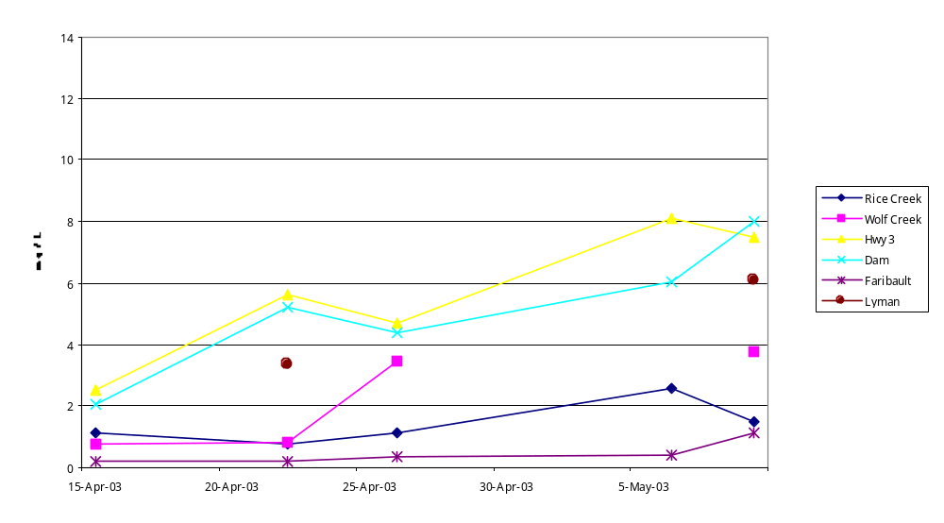
Figure 11 - Nitrate

Discussion
There are a number of possible sources of error for our study on the Cannon River. Although slight, there is always human error when making measurements especially with instruments like the Secchi tube. Also, a few times, our pH meter was not calibrated and therefore may have changed our results somewhat. Other ways in which error may have occurred include the river itself. After heavy rain at the end of April, the level of the river rose to the point where we were not able to reach the same locations from which we had taken samples previously. Also, the rainwater might have changed the levels of nutrients in the river water. Wildlife residing where we took or samples from may also have caused change in nutrient level, so we were never testing only 100% river water.
If we were to do this study again, there are a few things we would do differently. We may choose to test at different areas. For example, there is a wastewater treatment plant located on the river in Dundas. Also, we would choose sampling locations at places more consistently in the river’s current.

Conclusion
The Cannon River passes the Environmental Protection Agency’s requirements for healthy drinking water. Nonetheless, there are low levels of contaminants in the river. To understand why this may be, we look at where are test sites are located and what else is around the area. Our test site in Faribault may have been contaminated by factory output from the foods factory situated on the banks of the Cannon River. The Highway 3 site might have been contaminated by the road use. Road salts and other vehicle pollution may have drained into the river. The site in Northfield is most likely contaminated by urban sprawl. Located in downtown Northfield, this site had much litter gathered by the banks of the river. Our Rice Creek and Wolf Creek sites were mostly affected by wildlife. To make sure the river water remains safe, the levels of contaminants should continue to be monitored.

Acknowledgements
Thank you to Liz Clark for teaching us how to use the GIS program in order to put our information together.
Thank you also to Heather Hilchey for driving us to our test sites to collect data.
Thank you to Ben Harrison for explaining how to put our projects together for display.
We thank Joseph Graly and Heather Hilchey for editing our paper.
Thank you, Bereket Haileab, for teaching us that projects like this one make a difference.

Works Cited
“Cannon River.” Minnesota Department of Natural Resources.
<http://www.dnr.state.mn.us/canoeing/cannonriver/index.html> (21 Apr. 2003).
“Cannon River.” National Watershed Network. July 10, 2000.
<http://www.ctic.purdue.edu/cgi-bin/ ShowWatershed.exe?Watershed=Cannon+River+%28USGS%23%3A+07040002%29> (May 21, 2003).
“Cannon River Watershed Partnership.” Cannon River Watershed.
<http://nco.northfield.mn.us/crwp/> (06 May 2003).
“Cannon Watershed Profile.” United States Environmental Protection Agency.
<http://cfpub.epa.gov/surf/huc.cfm?huc_code=07040002 > (07 May 2003).
“Did You Know?” Cannon River Watershed Partnership.
<http://www.crwp.net/facts.html> (21 Apr. 2003).
Haileab, Bereket. “What are We Measuring and Why?” p. 2.
Kroening, Sharon and James Stark. “Variability of Nutrients in Streams in Part of the
Upper Mississippi River Basin, Minnesota and Wisconsin.” United States
Geological Survey Fact Sheet FS-164-97.
<http://mn.water.usgs.gov/164-97/text.htm> (24 Apr. 2003).
“List of Drinking Water Contaminants & MCLs.” U.S. Environmental Protection
Agency. 6 Mar. 2003. <http://www.epa.gov/safewater/mcl.html> (28 Apr. 2003).
“Northfield, MN.” Wunderground.com.
<http://www.wunderground.com/US/MN/Northfield.html> (26 May 2003).
“Removal of the Welch Dam.” American Rivers.
<http://www.amrivers.org/tableofcontents/sscannon.htm> (21 Apr. 2003).
“U.S. Geological Survey. 1990 Water Use for 07040002 – Cannon.” U.S.
Environmental Protection Agency. <http://water.usgs.gov/cgi-bin/wuhuc?huc=07040002> (28 Apr. 2003).

